Dashboard Design

Date | 25 July 2026
Project Name | Global Ai in Education
Maximum Marks | 5 Marks

Activity 1: Interactive and Visually Appealing Dashboards
- Dashboard 1
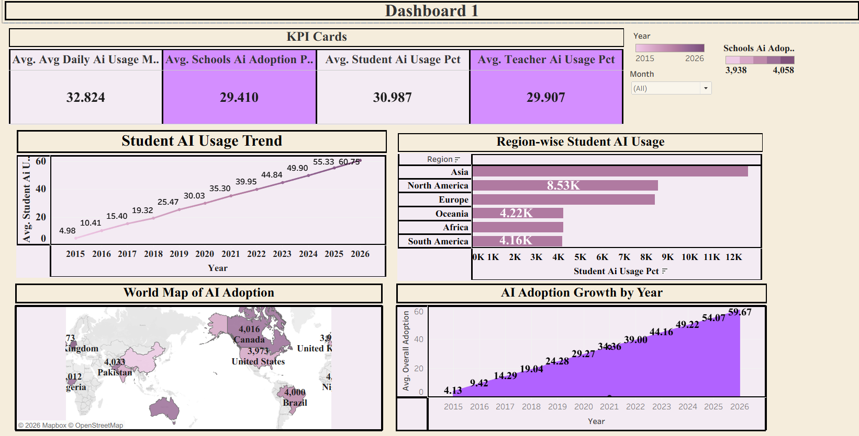

Dashboard 1 provides a comprehensive overview of AI adoption and usage trends in the education sector from 2015 to 2026. It highlights key performance indicators (KPIs), regional AI adoption, yearly growth, and country-wise school adoption, enabling stakeholders to evaluate the overall progress of AI integration in education.

Components of Dashboard 1
- KPI Cards: Display the average values of key metrics including Average Daily AI Usage, School AI Adoption Percentage, Student AI Usage Percentage, and Teacher AI Usage Percentage, offering a quick snapshot of overall AI adoption.
- Student AI Usage Trend: A line chart showing the steady increase in student AI usage over the years, helping identify long-term adoption trends.
- Region-wise Student AI Usage: A horizontal bar chart comparing student AI usage across different regions. It helps determine which regions are leading or lagging in AI adoption.
- World Map of AI Adoption: A geographic visualization illustrating school AI adoption levels across different countries. Darker shades indicate relatively higher adoption, allowing easy identification of leading nations.
- AI Adoption Growth by Year: An area chart presenting the year-wise growth of overall AI adoption, demonstrating the continuous expansion of AI implementation in educational institutions.
- Interactive Filters: Users can filter the dashboard by Year and Month to perform dynamic analysis and observe changes across different time periods.

Overall Insight
The dashboard indicates a consistent increase in AI adoption throughout the years. Student AI usage has grown significantly, with Asian countries showing the highest regional usage. The global map highlights countries actively implementing AI in education, while the KPI cards provide a concise summary of the overall adoption status.

- Dashboard 2
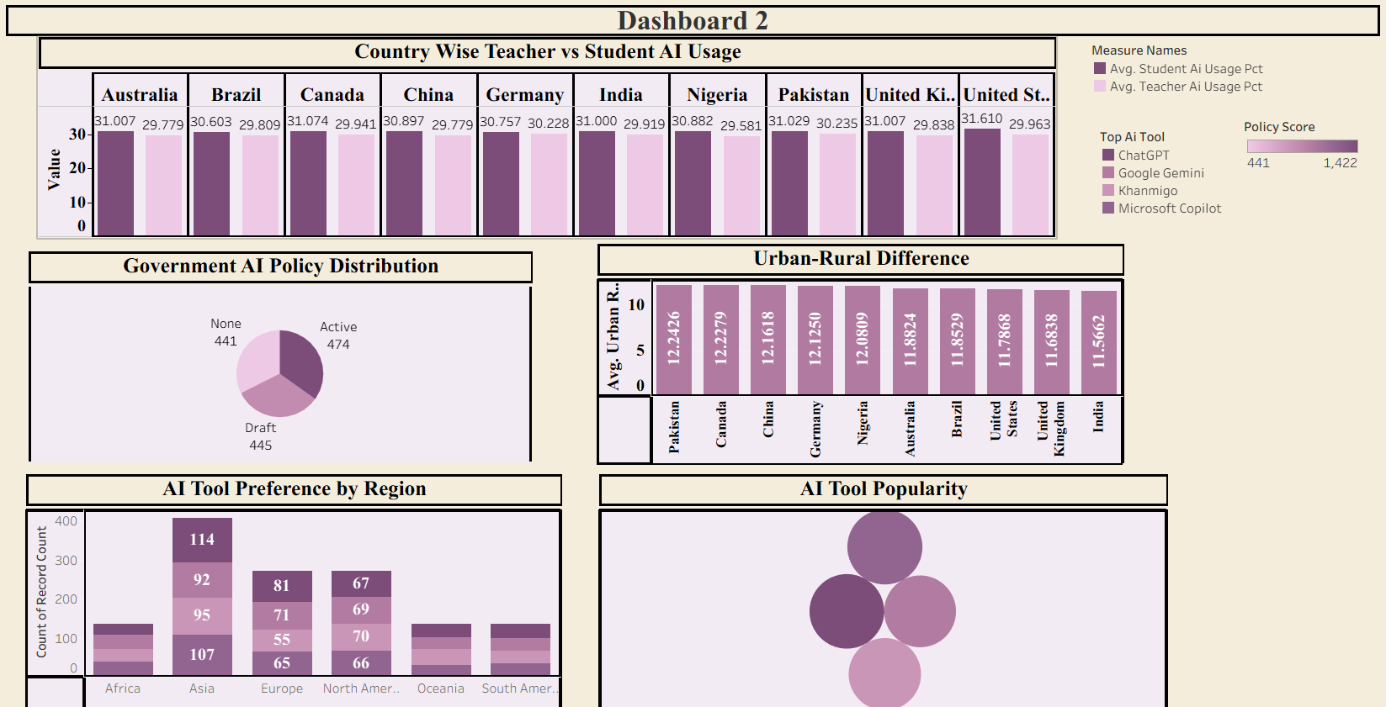

Dashboard 2 focuses on comparative and policy-based analysis of AI usage. It examines AI adoption among students and teachers, government AI policies, urban-rural differences, regional AI tool preferences, and the popularity of different AI tools.

Components of Dashboard 2
- Country-wise Teacher vs Student AI Usage: A grouped bar chart comparing average AI usage percentages between students and teachers for each country, helping identify adoption gaps among different user groups.
- Government AI Policy Distribution: A pie chart displaying the proportion of countries with different AI policy statuses (Active, Draft, and None), providing insight into governmental support for AI implementation.
- Urban-Rural Difference: A vertical bar chart illustrating AI usage differences between urban and rural populations across countries, highlighting the extent of the digital divide.
- AI Tool Preference by Region: A stacked bar chart showing the distribution of popular AI tools across various regions, enabling comparison of regional preferences for AI platforms.
- AI Tool Popularity: A bubble chart representing the overall popularity of major AI tools such as ChatGPT, Google Gemini, Khanmigo, and Microsoft Copilot. Larger bubbles indicate higher adoption and usage.
- Interactive Filters and Legends: Users can analyze the dashboard using filters for AI tools, policy scores, and measurement categories, making the dashboard interactive and easy to explore.

Overall Insight
The dashboard reveals that student AI usage is generally slightly higher than teacher AI usage across most countries. Government AI policy implementation varies considerably, with many countries still operating under draft or no formal AI policies. Urban areas consistently exhibit greater AI usage than rural areas, emphasizing the need to bridge the digital divide. Regional AI tool preferences differ, although ChatGPT and Google Gemini remain among the most widely adopted AI platforms globally.

Activity 2: Live Deployment Link
Below is the verified public access link to the interactive, cloud-hosted visualization story:
Tableau Public Dashboard Link:
https://public.tableau.com/app/profile/akshita.bhadauria/vizzes

